GENERALITIES OF THE PRODUCT

The discs for CAD/CAM application produced by New Stetic are made of poly methyl methacrylate (PMMA), a known material used in the dental field due their physical-chemical, mechanical and biocompatibility properties. These discs are intended for dental CAD/CAM use and have a standard format according to the commercial CAD/CAM machines specifications. Also, the CAD/CAM discs have a wide variety of colors and shapes.

The production of the Portux® CAD/CAM discs is founded on the ample experience and knowledge that New Stetic has in the manufacture of PMMA-based polymers and copolymers.

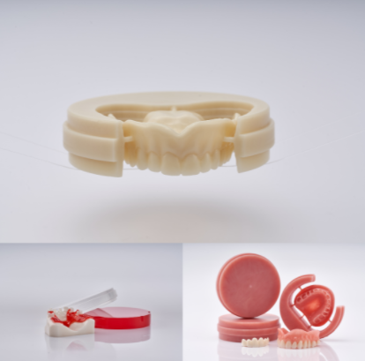

INFORMATION ABOUT COMPOSITION

The product is made from poly methyl methacrylate, which is the major component, pigments and modifier additives that allow obtaining the typical properties of the material that make it fit for CAM dental machining systems.

PROPERTIES OF THE PRODUCT

The table below shows some relevant properties of the product.

Property | Standards | Portux®  (Average value)
Flexural strength | > 65 MPa | 101 MPa
Flexural modulus | > 2000 MPa | 3100 MPa
Solubility | < 1.6 µg/mm³ | 0.4 µg/mm³
Residual monomer | < 2.2% | 0.7 %
Water absorption | < 32 µg/mm³ | 25 µg/mm³
Vickers hardness | N.A. | 20 HV (Q1)

USES AND APPLICATIONS

Portux® PMMA discs from New Stetic are intended for their use in CAD/CAM technology for dental application. They have a standard format in accordance with the specifications of commercial CAM machines.

The PMMA discs are directly used by the dentist or dental technician for the manufacturing of dental structures with CAD/CAM technology. The variants of the product include the following applications:

- Provisional anterior and posterior crowns & bridges.
- Implant supported prosthetics.
- Partial, complete and hybrid denture prosthetics (base and teeth).
- Removable appliances (splint).
- Copy of dental metallic structures by casting method.

The product has excellent properties for long term provisional use.

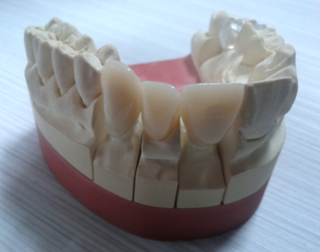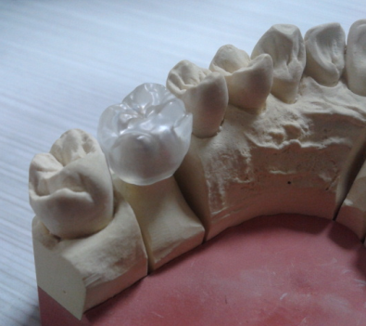

QUALITY ASSURANCE OF THE PRODUCT

The product quality is guaranteed through the application of standardized analytical methodologies validated by means of using calibrated equipment. Based on this, the Quality Control Laboratory assures quality of the product from its raw materials up to the finished product.

INSTRUCTIONS FOR USE

- The disc format must fit the configuration of the CAM machine used.
- Set the disc in the milling machine according to the instructions given for the equipment.
- If a multi-layer disc is used, place it properly in such a manner that it has a correct color profile in the machined piece.
- Avoid overheating of the material during the machining.
- After the machining, take out the disc from the equipment and remove the piece obtained.
- Perform the finishing process in accordance with the specifications of the job made.

The detailed indications for the correct use of the product are described in the instructions for use.

COMMERCIAL PRESENTATIONS

Portux® PMMA CAD/CAM discs are available in the following colors and dimensions per unit.

7.1 Colors:

Type of disc | Colors
Single-color | A1, A2, A3, A3.5, BL, BL2, BL3 B1, B2, B3, C1, C2, D2, D3.
Multi-layer | A1, A2, A3, A 3.5, B1, B2, BL, C1, C2, C3, D2, D3.
Castable | Transparent and red.
Denture Base | Original, Meharry

  - Dimensions:

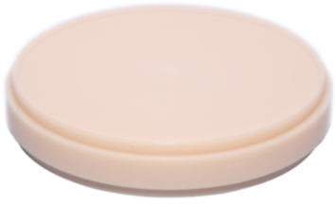
Diameter: 98.5 mm
Thicknesses: 14, 16, 18, 20, 25, 30 and 35 mm

8. STORAGE AND PRESERVATION CONDITIONS

Keep the product in a fresh and dry place at a temperature ≤ 30 °C. Avoid heat sources and direct sunlight. Do not store with incompatible chemical substances such as organic solvents.
Fecha de Creación |  | Elaborado por: | Revisado por:
2009-09-04 |  | Analista de Diseño y Desarrollo | Directora Técnica DM
Clase | Página | Aprobado por: | Fecha de Actualización | Versión
E | 4 de 4 | Directora Técnica DM | 2017-10-03 | 05
DOCUMENTO DE REFERENCIA:
VERSIÓN:

