GENERALITIES OF THE PRODUCT

Saliva ejectors are medical devices that are used directly into the mouth in order to evacuate the fluids (water, saliva, blood, exudate) which are generated during the dental procedures.

The E-Jet ejectors are optimum to keep the oral cavity dry and thus the dentist can work comfortly at a fluid-free area.

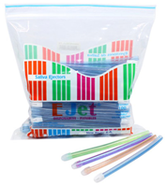

Its design lets an easy handling and bending without collapsing in order to be adapted to the work in mouth. The ejector is connected easily to the vacuum unity and it does not hurt the patients’ soft tissues thanks to rounded edges of the nozzle.

COMPOSITION INFORMATION

E-Jet ejectors are made with materials which do not cause any kind of allergy or toxicity, besides these materials are used largely for these kinds of devices.

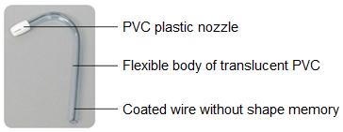

The plastic material of both nozzle and body is safe and it does not cause adverse effects when it is in contact with the oral tissues, and because its use is temporary.

The rounded edges of the nozzle avoid any kind of wound and the coated wire without form memory lets the ejector keeps its position when it is blended. The translucent body lets better visibility and control about its operation.

PROPERTIES OF THE PRODUCT

The applications of PVC in medical field are very known, this has been possible thanks to the characteristics offered by this material: Versatility, reliability, safety, practicality, strength and biocompatibility. Thanks to this PVC is used in the manufacture of medical devices such as flexible bags for the collection and storage of fluids and drugs, tubes and hoses for transporting fluids, cannulas, catheters, masks inhalation, equipments for parenteral nutrition, packaging of medicines, syringes, disposable gloves, development of artificial organs, prostheses, orthopedic implements, etcetera. This is the same material used for the manufacture of E-Jet saliva ejectors, reason why this kind of dental device guarantees safety for the patient.

USE Y APPLICATIONS

Saliva ejectors are used directly into the mouth and on its floor in order to evacuate the fluids generated during the dental procedures.

The product does not require special conditions for its use, that is the reason why the dentist can use it for any kinds of patient having absolute confidence and security.

Ejectors are disposable devices for single-use only, they must be immediately discarded as waste with biological risk. For its design and expected use, they must not be used as high volume or high-power suction ejectors, neither are intended to be used in surgical procedures, they must not be washed, sterilized nor disinfected for its conventional use.

QUALITY ASSURANCE OF THE PRODUCT

The internal controls applied lot by lot let being sure the parameters of the product in order to guarantee its working.

In addition to the process controls the Quality Control Lab verifies the standards of the product using calibrated equipments. The main physical characteristics are shown in following figure.

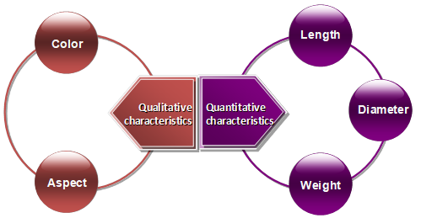

USE INSTRUCTIONS

- Connect the end contrary to the nozzle to the hose of the vacuum unity.
- Bend the ejector bearing in mind the wire be located laterally to improve the suction like the figure shows.
- Introduce the ejector placing the nozzle on the floor of the mouth, that is to say, under the patient’s tongue.

COMMERCIAL PRESENTATIONS

- Bag x 50 and 100 ejectors.
- Colors: Blue, purple, orange, transparent, green, yellow and aquamarine.

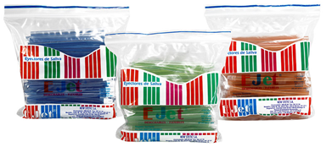

Dimensions:

Color | Length (cm)
Blue, purple, orange, green, yellow and aquamarine | 13 and 15
Transparent | 15

STORAGE AND PRESERVATION CONDITIONS

The product does not require special storage conditions; however, the following conditions must be avoided:

• Direct exposure to sunlight or other types of strong radiation.
• Sources of heat or humidity.
• Dust or other sources of contamination.

The product should preferably be kept inside its original packaging, safeguarded from the conditions mentioned above.

